PIZZA SALES SQL QUERES

A .KPI’S

1.Total Revenue

select SUM(total_price) as total_revenue from pizza_sales;

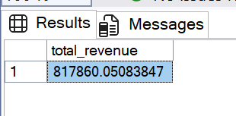

2. Average order values

select SUM(total_price)/count(distinct order_id) as Average_order_values from pizza_sales;

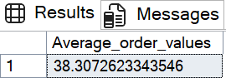

3. Total pizza sold

select sum(quantity) as total_pizza_sold from pizza_sales;

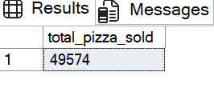

4.Total Orders

select count( distinct order_id) AS total_orders from pizza_sales;

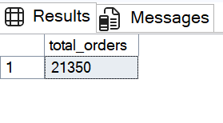

5. Average pizzas per order

select cast(cast(sum(quantity)AS decimal(10,2))/count(distinct order_id) As decimal(10,2)) as Average_pizzas_per_order from pizza_sales;

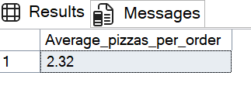

B. Daily trend for total order

select datename(DW,order_date) AS order_day,count(distinct order_id) as total_order

from pizza_sales

group by datename(DW,order_date);

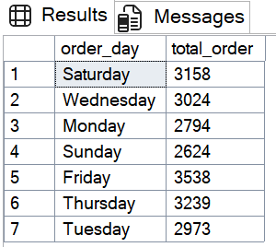

C. Hourly Trend for total order

select datepart(HOUR,order_time) as order_time,count(distinct order_id) as total_order

from pizza_sales

group by datepart(HOUR,order_time)

order by order_time asc;

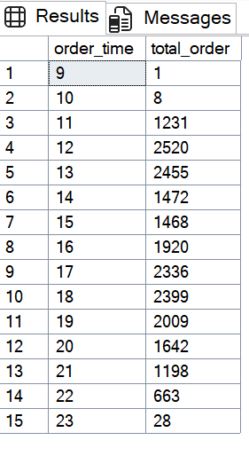

D. percentage of sales by pizza category

select pizza_category ,sum(total_price)*100/(select sum(total_price) from pizza_sales) as per_of_sales

from pizza_sales

group by pizza_category

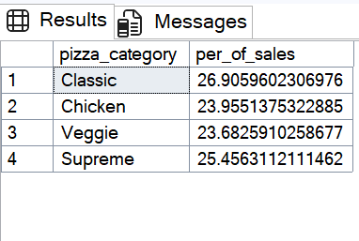

E.percentage of sale by pizza size

select pizza_size ,sum(total_price)*100/(select sum(total_price) from pizza_sales) as per_of_sales

from pizza_sales

group by pizza_size

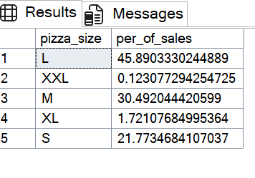

F. total pizza sold by category

select pizza_category,sum(quantity) as total_piza from pizza_sales

group by pizza_category

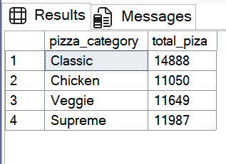

G. Top 5 best seller by total pizza sold

select top 5 pizza_name,sum(quantity) as total_pizza_sold from pizza_sales

group by pizza_name

order by total_pizza_sold desc

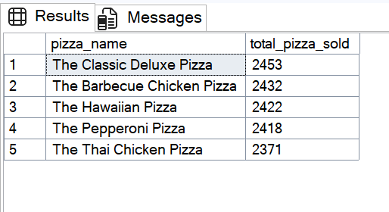

H. Bottom 5 Worst seller by total pizza sold

select top 5 pizza_name,sum(quantity) as total_pizza_sold from pizza_sales

group by pizza_name

order by total_pizza_sold asc

